**TECHNO INDIA COLLEGE OF TECHNOLOGY**

Name – Anik Paul

Stream – BCA (3rd Year, 5th Sem)

Reg. no.- 213141001210002 OF 2021-22

University Roll No.- 31401221038

Subject Code – BCAC591

Subject – Internet Technology Lab

Topic: LIQUOR WEBSITE

Session – 2021-2024

**LOGIN HTML:**

<!DOCTYPE html>

<html lang="en">

<head>

<meta charset="UTF-8">

<meta name="viewport" content="width=device-width, initial-scale=1.0">

<title>WINEHUB</title>

<link rel="stylesheet" href="login.css">

</head>

<body>

<body style="background-image: url('landscape-table-wine-bottle-wallpaper-preview.jpg'); background-repeat: no-repeat; background-attachment: fixed;background-size: 100% 100%;"></body>

<div class="container">

<form action="process_login.php" method="POST">

<h2>Login</h2>

<label for="username">Username</label>

<input type="text" id="username" name="username" required>

<label for="password">Password</label>

<input type="password" id="password" name="password" required>

<button class="b" type="submit" formaction="home.html">Login</button>

</form>

</div>

</body>

</html>

**LOGIN CSS**:

/* Reset some default styles */

* {

margin: 0;

padding: 0;

box-sizing: border-box;

}

body {

font-family: Arial, sans-serif;

background-color: rgba(223, 234, 122, 0.438);

}

.container {

background-color: transparent;

width: 300px;

margin: 0 auto;

margin-top: 100px;

padding: 20px;

border-radius: 20px;

box-shadow: 0 10px 10px rgb(232, 39, 84)

}

h2 {

text-align: center;

margin-bottom: 20px;

}

label {

display: block;

margin-bottom: 8px;

}

input[type="text"],

input[type="password"] {

width: 100%;

padding: 10px;

margin-bottom: 20px;

border: 1px solid #aeffa3;

border-radius: 3px;

box-shadow: 0 3px 10px rgb(20, 214, 201)

}

button {

width: 100%;

padding: 10px;

background-color: #95cfaea9;

color: #1c0c0d;

border: none;

border-radius: 3px;

cursor: pointer;

}

button:hover {

background-color: rgba(79, 230, 59, 0.664);

}

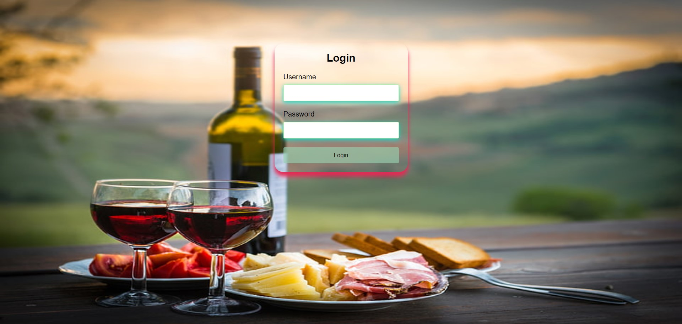

**HOME.HTML:**

<!DOCTYPE html>

<html lang="en">

<head>

<meta charset="UTF-8">

<meta name="viewport" content="width=device-width, initial-scale=1.0">

<title>WINEHUB</title>

<link rel="stylesheet" href="home.css">

</head>

<body>

<body style="background-image: url('homebg.jpg'); background-repeat: no-repeat; background-attachment: fixed;background-size: 100% 100%;"></body>

<header>

<nav>

<ul>

<li><a href="home.html">HOME</a></li>

<li><a href="cart.html">CART</a></li>

<button class="button" onclick="window.location.href='login.html';">Login</button>

</ul>

</nav>

<h1>Welcome to WINEHUB</h1>

<p>Discover a world of fine spirits and drinks.</p>

</header>

<section class="featured-products">

<h2>Featured Products</h2>

</section>

<div class="product">

<img src="wishkey.jpg" alt="Whiskey">

<h3>Whiskey</h3>

<p>Explore our wide range of premium whiskeys.</p>

</div>

<div class="product">

<img src="wine.jpg" alt="Wine">

<h3>Wine</h3>

<p>Discover our exquisite selection of wines from around the world.</p>

</div>

<div class="product">

<img src="vodka.jpg" alt="Vodka">

<h3>Vodka</h3>

<p>Experience the purity and taste of our finest vodkas.</p>

</div>

<div class="product">

<img src="beer.jpg" alt="Beer">

<h3>Beer</h3>

<p>Experience the beautiful taste of beers.</p>

</div>

</section>

<section class="about-us">

<h2>About Us</h2>

<p>"Discover exceptional wines at Our Wine Shop. We offer a curated selection of fine wines from around the world, expert recommendations, and a warm, welcoming atmosphere. Join us for a sip of elegance today."</p>

</section>

<footer>

<p>&copy; WINEHUB | HELPLINE: 033-9330123459 |ESTD:2018</p>

</footer>

</body>

</html>

**HOME CSS:**

<!DOCTYPE html>

<html lang="en">

<head>

<meta charset="UTF-8">

<meta name="viewport" content="width=device-width, initial-scale=1.0">

<title>WINEHUB</title>

<link rel="stylesheet" href="home.css">

</head>

<body>

<body style="background-image: url('homebg.jpg'); background-repeat: no-repeat; background-attachment: fixed;background-size: 100% 100%;"></body>

<header>

<nav>

<ul>

<li><a href="home.html">HOME</a></li>

<li><a href="cart.html">CART</a></li>

<button class="button" onclick="window.location.href='login.html';">Login</button>

</ul>

</nav>

<h1>Welcome to WINEHUB</h1>

<p>Discover a world of fine spirits and drinks.</p>

</header>

<section class="featured-products">

<h2>Featured Products</h2>

</section>

<div class="product">

<img src="wishkey.jpg" alt="Whiskey">

<h3>Whiskey</h3>

<p>Explore our wide range of premium whiskeys.</p>

</div>

<div class="product">

<img src="wine.jpg" alt="Wine">

<h3>Wine</h3>

<p>Discover our exquisite selection of wines from around the world.</p>

</div>

<div class="product">

<img src="vodka.jpg" alt="Vodka">

<h3>Vodka</h3>

<p>Experience the purity and taste of our finest vodkas.</p>

</div>

<div class="product">

<img src="beer.jpg" alt="Beer">

<h3>Beer</h3>

<p>Experience the beautiful taste of beers.</p>

</div>

</section>

<section class="about-us">

<h2>About Us</h2>

<p>"Discover exceptional wines at Our Wine Shop. We offer a curated selection of fine wines from around the world, expert recommendations, and a warm, welcoming atmosphere. Join us for a sip of elegance today."</p>

</section>

<footer>

<p>&copy; WINEHUB | HELPLINE: 033-9330123459 |ESTD:2018</p>

</footer>

</body>

</html>

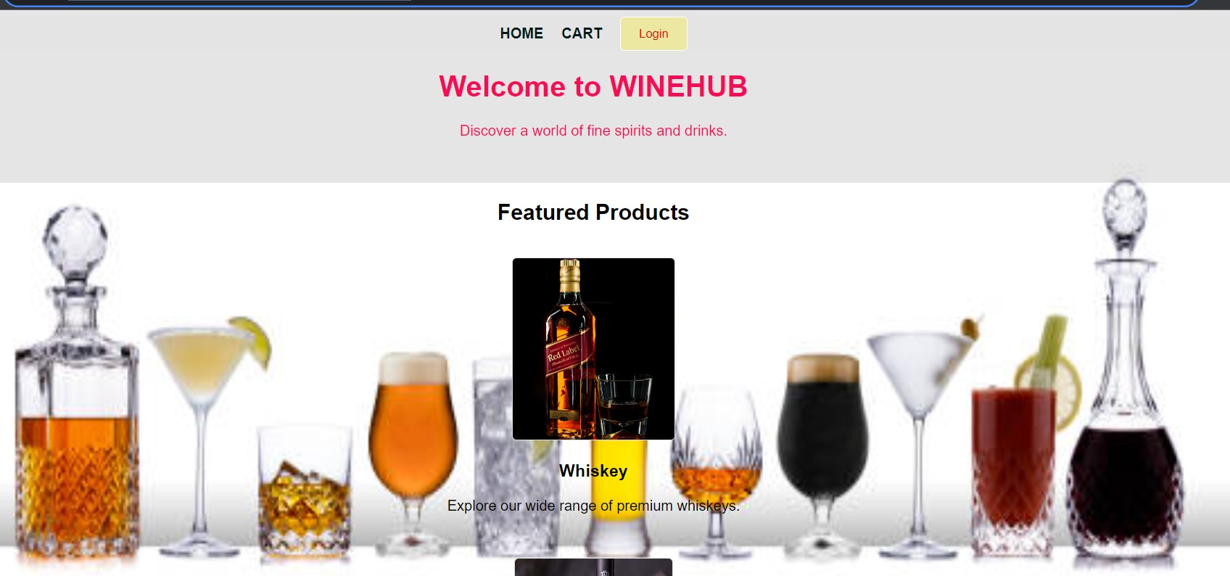

**ABOUT & TEARMS & CONDITIONS HTML:**

<!DOCTYPE html>

<html lang="en">

<head>

<meta charset="UTF-8">

<meta name="viewport" content="width=device-width, initial-scale=1.0">

<title>WINEHUB</title>

<link rel="stylesheet" type="text/css" href="About &tearms.css">

</head>

<body>

<body bgcolor="SDAPDP">

<header>

<nav>

<ul>

<li><a href="home.html">Home</a></li>

<li><a href="cart.html">Cart</a></li>

</ul>

</nav>

</header>

<div id="about">

<h1>About Us</h1>

<p>

Welcome to Our WINEHUB, your premier destination for the finest liquors from around the globe. Founded in 2018, we have been dedicated to sourcing and delivering exceptional beverages to our discerning clientele. Our commitment to quality, integrity, and unparalleled customer service sets us apart in the industry. Join us on a journey through the world of spirits, where tradition meets modernity.

</p>

</div>

<div id="terms">

<h2>Terms & Conditions</h2>

<ol>

<li>Age Restriction: You must be 18 years or older to use this website and purchase products from Our WINEHUB. Proof of age may be required upon delivery.</li>

<li>Ordering: All orders are subject to availability and confirmation of order price.</li>

<li>Shipping: We only ship to verified addresses within regions where alcohol delivery is legally permissible.</li>

<li>Returns & Refunds: Goods must be returned unopened and in the original packaging. Returns are subject to a restocking fee.</li>

<li>Liability: Our WINEHUB is not responsible for any damage or injury caused by the misuse of our products.</li>

<li>Website Use: All content on this website is property of Our WINEHUB. Unauthorized reproduction is prohibited.</li>

<li>Modifications: We reserve the right to modify these terms & conditions at any time without prior notice.</li>

<!-- Add more terms as needed -->

</ol>

<p>By using this website and placing an order, you agree to be bound by the aforementioned terms & conditions.</p>

</div>

</body>

</html>

**ABOUT & TEARMS & CONDITIONS CSS:**

/* styles.css */

body {

font-family: Arial, sans-serif;

padding: 20px;

line-height: 20px;

margin: 0;

}

header {

background-color:rgba(240, 221, 221, 0.452) ;

color: rgb(255, 255, 255);

padding: 10px 0;

}

nav ul {

list-style: none;

text-align: center;

margin: 0;

padding: 0;

}

nav li {

display: inline;

margin: 0 20px;

}

nav a {

text-decoration: none;

color: rgb(255, 255, 255);

transition: color 0.3s;

}

nav a:hover {

color: #f07509;

}

#about, #terms {

border: 1px solid #ccc;

padding: 20px;

margin: 20px;

}

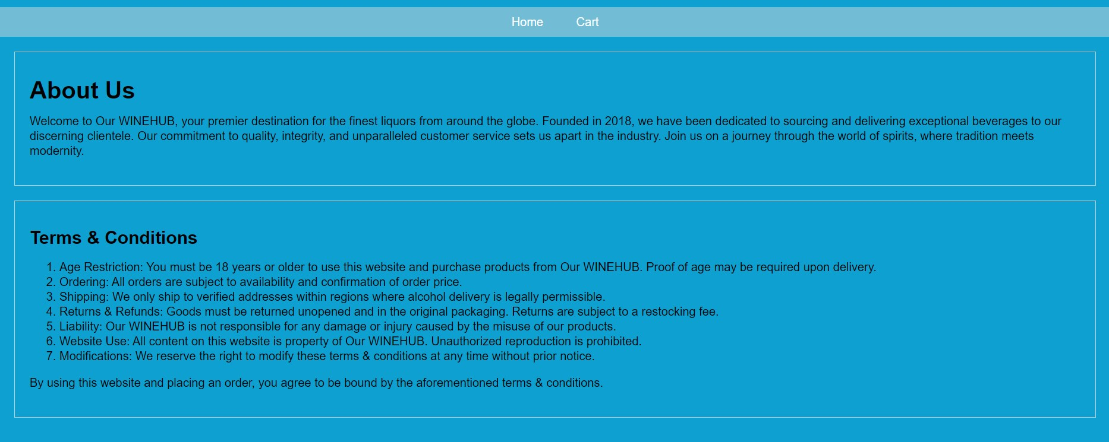

**CART HTML:**

<!DOCTYPE html>

<html lang="en">

<head>

<meta charset="UTF-8">

<meta name="viewport" content="width=device-width, initial-scale=1.0">

<link rel="stylesheet" href="cart.css">

<title>WINEHUB</title>

</head>

<body>

<body style="background-image: url('cart bg.jpg'); background-repeat: no-repeat; background-attachment: fixed;background-size: 100% 100%;"></body>

<header>

<nav>

<div class="navbar-container">

<ul class="nav-list">

<li><a href="home.html">Home</a></li>

<li><a href="About &tearms.html">About Us</a></li>

<li><a href="About &tearms.html">Terms & Conditions</a></li>

</ul>

<button class="button" onclick="window.location.href='login.html';">Login</button>

</div>

</nav>

</header>

<main>

<div class="product 1">

<img src="https://images.unsplash.com/photo-1534221905680-192a9a88ac81?ixlib=rb-4.0.3&ixid=M3wxMjA3fDB8MHxzZWFyY2h8Mnx8cmVkJTIwbGFiZWx8ZW58MHx8MHx8fDA%3D&w=1000&q=80" alt="Red Level">

<h2>Red Level</h2>

<p>Available</p>

<p>Price: $10.00</p>

<button class="add-to-cart">Add to Cart</button>

</div>

<div class="product 2">

<img src="https://us.123rf.com/450wm/korolkoff/korolkoff1803/korolkoff180300078/119171152-los-angeles-ca-photo-of-a-12-ounce-bottle-of-corona-extra-beer-water-drops-on-a-bottle-corona-is.jpg?ver=6" alt="Corona Extra">

<h2>Corona Extra</h2>

<p>Available.</p>

<p>Price: $08.00</p>

<button class="add-to-cart">Add to Cart</button>

</div>

<div class="product 3">

<img src="https://kalailiquor.com/wp-content/uploads/2020/10/imperial-blue.jpg" alt="Imperial Blue">

<h2>Imperial Blue</h2>

<p>Available</p>

<p>Price: $18.00</p>

<button class="add-to-cart">Add to Cart</button>

</div>

<div class="product 4">

<img src="https://booznow.com/wp-content/uploads/2020/05/0020054_seagrams-royal-stag-whisky_600.jpeg" alt="Royal Stag">

<h2>Royal Stag</h2>

<p>Available</p>

<p>Price: $28.00</p>

<button class="add-to-cart">Add to Cart</button>

</div>

<div class="product 5">

<img src="https://lovelypackage.com/wp-content/uploads/2012/10/lovely-package-skyy-vodka.jpg" alt="Skyy Vodka">

<h2>Skyy Vodka</h2>

<p>Available</p>

<p>Price: $21.00</p>

<button class="add-to-cart">Add to Cart</button>

</div>

<div class="product 6">

<img src="https://images.unsplash.com/photo-1521201795527-a80e2debb4c8?ixlib=rb-4.0.3&ixid=M3wxMjA3fDB8MHxzZWFyY2h8MXx8amFjayUyMGRhbmllbHN8ZW58MHx8MHx8fDA%3D&w=1000&q=80" alt="Jack Daniels">

<h2>Jack Daniels</h2>

<p>Available</p>

<p>Price: $35.00</p>

<button class="add-to-cart">Add to Cart</button>

</div>

<div class="product 7">

<img src="https://glensandtonics.com/cdn/shop/products/m16010_4.jpg?v=1647966872" alt="Captain Morgan">

<h2>Captain Morgan</h2>

<p>Available</p>

<p>Price: $35.00</p>

<button class="add-to-cart">Add to Cart</button>

</div>

<div class="product 8">

<img src="https://shreeramkenya.com/wp-content/uploads/2021/01/IMG_8174-scaled.jpg" alt="Smrinoff">

<h2>Smrinoff</h2>

<p>Available</p>

<p>Price: $25.00</p>

<button class="add-to-cart">Add to Cart</button>

</div>

<div class="product 9">

<img src="https://i.pinimg.com/originals/11/57/b6/1157b61baf1378079e005ef3d4e8bc72.jpg" alt=" Grey Goose">

<h2> Grey Goose</h2>

<p>Not Available now</p>

<p>Price: $1,500,000,000</p>

<button class="add-to-cart">Add to Cart</button>

</div>

<div class="product 10">

<img src="https://aem.lcbo.com/content/dam/lcbo/products/1/1/4/6/114694.jpg.thumb.1280.1280.jpg" alt=" Crown Royal">

<h2> Crown Royal</h2>

<p>Available</p>

<p>Price: $1,500,000,000</p>

<button class="add-to-cart">Add to Cart</button>

</div>

<div class="product 11">

<img src="https://i.pinimg.com/1200x/a9/76/12/a97612272bdbfdee784169c5e7770dc4.jpg" alt="Old Monk">

<h2> Old Monk</h2>

<p>Available</p>

<p>Price: $500,20</p>

<button class="add-to-cart">Add to Cart</button>

</div>

</main>

</body>

</html>

**CART CSS:**

/* Reset some default browser styles */

* {

margin: 0;

padding: 0;

box-sizing: border-box;

font-family: Arial, sans-serif;

transition: all 0.3s ease-in-out;

}

body {

background-color: rgba(244, 244, 244, 0.408);

}

/* Style the navigation bar */

header {

background-color: rgba(39, 2, 2, 0);

color: white;

}

.navbar-container {

display: flex;

justify-content: space-between;

align-items: center;

padding: 0 20px;

}

.nav-list {

list-style: none;

display: flex;

}

.nav-list li {

margin: 0 20px;

position: relative;

}

.nav-list a {

text-decoration: none;

color: rgb(248, 248, 248);

font-weight: bold;

padding: 15px 10px;

display: block;

position: relative;

}

.nav-list a::before {

content: '';

position: absolute;

width: 0;

height: 2px;

bottom: 0;

left: 50%;

background-color: rgb(6, 110, 42);

transition: all 0.3s ease-in-out;

transform: translateX(-50%);

}

.nav-list a:hover::before {

width: 100%;

}

nav button {

background-color: rgba(240, 234, 118, 0.615);

padding: 10px 20px;

color: rgb(231, 5, 5);

border: 1px solid rgb(255, 255, 255);

padding: 10px 20px;

border-radius: 5px;

cursor: pointer;

}

nav button:hover {

background-color: rgba(255, 255, 255, 0.601);

color: #0487f3;

}

/* Style the product container */

.product {

background-color: rgba(255, 255, 255, 0.623);

text-align: center;

margin: 40px auto;

width: 350px;

max-width: 600px;

padding: 20px;

border: 1px solid rgba(204, 204, 204, 0.818);

border-radius: 5px;

box-shadow: 0 3px 10px rgb(136, 232, 39)

}

.product img {

max-width: 100%;

height: 200px; /* Set a fixed height for images, adjust as needed */

border-radius: 5px;

}

.product h2 {

margin: 15px 0;

}

.product p {

margin: 5px 0;

}

.product button.add-to-cart {

background-color: rgba(161, 128, 93, 0.914);

color: rgb(251, 8, 76);

border: none;

padding: 10px 20px;

border-radius: 5px;

cursor: pointer;

font-size: 16px;

margin-top: 20px;

}

.product button.add-to-cart:hover {

background-color: #f1e42dc2;

}

